**Lab 14: Android Horizontal ScrollView**

# **Introduction**

# A FrameLayout is a HorizontalScrollView. the widget for android. The functionality of a horizontal scroll view is provided by the class HorizontalScrollView. The child components or views are scrolled horizontally using the HorizontalScrollView. Only horizontal scrolling is supported by the HorizontalScrollView. Android uses ScrollView for vertical scrolling.

**Let’s get Started:**

**Step 1: Create a New Project in Android Studio as shown below**

**Step 2: Select Empty Activity as shown below**

**Step 3: Provide a Project Name as shown below**

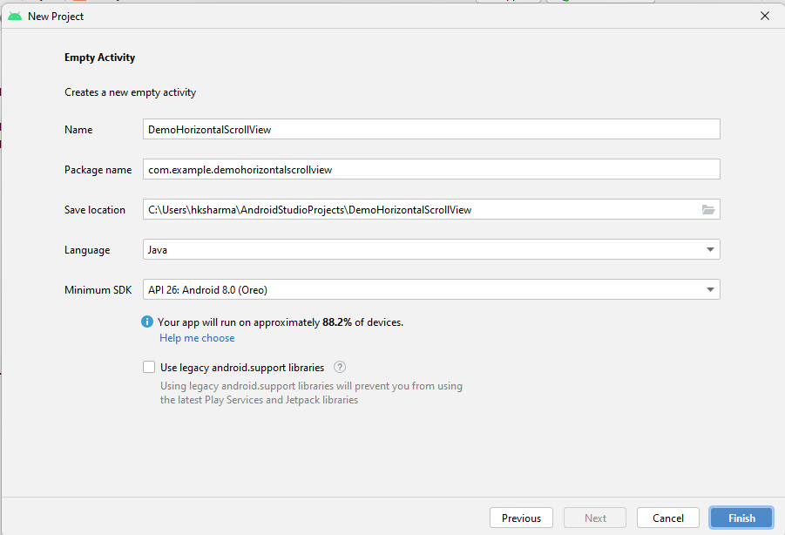

**Step 4: Update MainActivity.java as per the code given below**

**package** com.example.demohorizontalscrollview;  
  
**import** androidx.appcompat.app.AppCompatActivity;  
  
**import** android.os.Bundle;  
  
**public class** MainActivity **extends** AppCompatActivity {  
  
 @Override  
 **protected void** onCreate(Bundle savedInstanceState) {  
 **super**.onCreate(savedInstanceState);  
 setContentView(R.layout.***activity_main***);  
 }  
}

**Step 5: Update activity_main.xml for Vertical Orientation as per the code given below**

*<?***xml version="1.0" encoding="utf-8"***?>*<**RelativeLayout xmlns:android="http://schemas.android.com/apk/res/android"  
 android:layout_width="fill_parent"  
 android:layout_height="fill_parent"**>  
 <**TextView  
 android:layout_width="wrap_content"  
 android:layout_height="wrap_content"  
 android:textAppearance="?android:attr/textAppearanceSmall"  
 android:text="My Horizontal ScrollView Example"  
 android:id="@+id/textView"  
 android:layout_alignParentTop="true"  
 android:layout_centerHorizontal="true"** />  
  
 <**LinearLayout  
 android:layout_width="match_parent"  
 android:layout_height="match_parent"  
 android:layout_marginTop="25dp"**>  
 <**HorizontalScrollView  
 android:layout_width="match_parent"  
 android:layout_height="60dp"  
 android:id="@+id/horizontalScrollView"**>  
  
 <**LinearLayout  
 android:layout_width="wrap_content"  
 android:layout_height="wrap_content"  
 android:orientation="horizontal"**>  
 <**Button  
 android:layout_width="wrap_content"  
 android:layout_height="wrap_content"  
 android:text="Button 1"  
 android:id="@+id/button1"** />  
 <**Button  
 android:layout_width="wrap_content"  
 android:layout_height="wrap_content"  
 android:text="Button2"  
 android:id="@+id/button2"** />  
 <**Button  
 android:layout_width="wrap_content"  
 android:layout_height="wrap_content"  
 android:text="Button3"  
 android:id="@+id/button3"** />  
 <**Button  
 android:layout_width="wrap_content"  
 android:layout_height="wrap_content"  
 android:text="Button4"  
 android:id="@+id/button4"** />  
 </**LinearLayout**>  
  
 </**HorizontalScrollView**>  
 </**LinearLayout**>  
</**RelativeLayout**>

**Step 6: Check Output on Android Emulator and it should look like as given below**

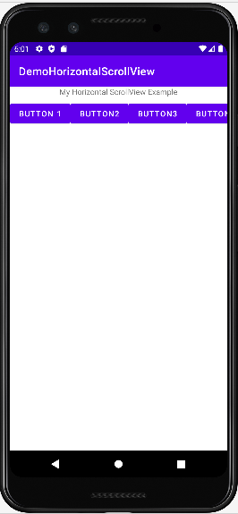

**Voila!!** We have successfully completed this lab.